

Module Code: PLP24103 BSM
Module Name: Professional Life Practice 1 – Developing Your Practice
Title: “Portfolio of Personal Branding: Developing My Professional Identity and Employability Skills at Ravensbourne University London”
Student Name & ID:
Submission Date:
Word Count: 2500

Table of Contents
1. Clarity 3
1.1 Part One- My Foundations 3
1.1.1 Choice of Business Management 3
1.1.2 Previous Experiences 4
1.1.3 Importance of Success 4
1.1.4 My Strengths, and Valuation 5
1.2 Future Implications 6
1.2.1 Skills I Need to Develop 6
1.2.2 Skills Needed After Graduation 6
1.2.3 SMART Plan 7
1.2.4 Preferred Career Sector and Job Role 7
2. Creativity 8
2.1 About Me (Website Content) 8
2.2 How My Website Represents My Personal Brand 8
2.3 My Target Audience 9
2.4 Website Structure Diagram 9
3. Connection 10
3.1 Events 10
3.2 Two Classroom Activities 12
3.3 Three Personal or Professional Connections 13
References 15

Link to the Employability Skills Log (ESL) website
https://prithamveersingh.myportfolio.com/

1. Clarity

1.1 Part One- My Foundations

1.1.1 Choice of Business Management
The Business management course at Ravenbourne University London is one of the significant steps that I took for achieving the career aspirations I have. Before taking admission in this university, my aim was to become a business consul;tamat which requires both theoretical understanding and practical skills within the field.
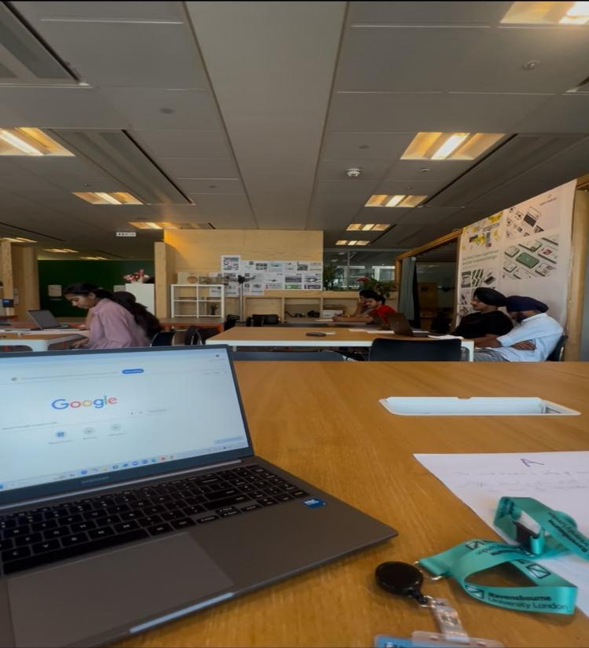
Figure 1: Individual study space
(Source: Ravensbourne University)
The reason why I chose to attend Ravensbourne University is because of project-based learning, collaboration and employability. I would like to study at a university which would not only teach me theoretical knowledge, but also create my skills in collaboration, communication and problem solving. In my first semester, I have realized that while working in a team, it is necessary to create my thoughts confidently while considering the viewpoints of others before making any decision. All these experiences made me more flexible and responsive.
Figure 1 shows my place of independent study where I constantly do my homework and prepare for tutorials and develop my research skills. Though there are other universities which offer courses in Business Management, Ravensbourne University will provide me with more opportunities in terms of industry exposure and learning more transferable skills. The importance of digital and transferable skills for graduate employability is proved by Universities UK (2024). Thus, studying at Ravensbourne University gives me an opportunity to obtain necessary knowledge and experience to become a good business professional.

1.1.2 Previous Experiences
Despite the lack of any experiences of attending university previously, I managed to develop some transferable skills owing to my academic experience and my experience as an academic writer and a teacher. As a teacher, I have developed my skills of patience, communication and adaptability because it was necessary to explain the same concept to learners with different skills. Besides, as an academic writer, I have developed my skills of research, analytical thinking and time management because it was necessary to complete a piece of writing in time. According to the World Economic Forum Future of Jobs Report, analytical thinking, resilience and lifelong learning are the most important skills for future employment.
However, despite gaining these experiences in Ravensbourne University, I had to adapt to a new learning environment where collaboration and teamwork were of vital importance. While working in a team, I realized that considering different viewpoints led to decision-making. This experience made me more open-minded and prepared me to collaborate with different professionals.

1.1.3 Importance of Success
Success at Ravensbourne University means much more for me than obtaining good grades. Even though academic success is very important, I am sure that success is determined by the development of necessary knowledge, confidence and professional skills helping to build a successful career after graduation. My aim is to use all the opportunities offered by the university to develop my skills of communication, leadership and problem solving and to gain practical experience through projects and industry exposure. HESA (2023) claims that the results of graduates depend increasingly on the combination of academic success and employability skills learned at the university. That is why these experiences encouraged me to actively participate in class debates, workshop activities without relying just upon my academic performance.
Moreover, I reel;arsisng that success can only be achieved by undertaking development which has discipline and consistency. During my course in this university, I understood what the meaning of corporate effectively is with peers and accepting constructive criticism from them. All these experiences played a crucial role in my personal development. Thus, by keeping a positive attitude and optimizing my skills, I would be able to achieve my aim of becoming a business consultant, contributing to my development in the future.

1.1.4 My Strengths, and Valuation
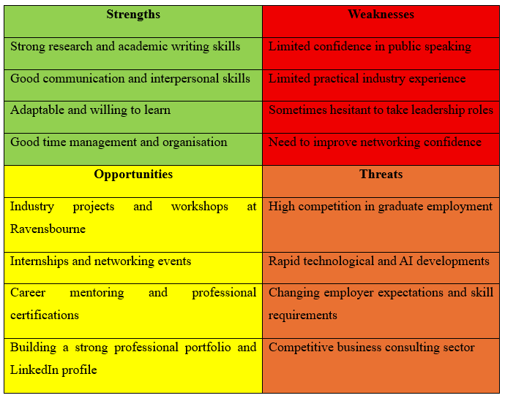
Table 1: Personal SWOT analysis
(Source: Self-created)
By studying in academic and professional environments, I have found some personal strengths helping me to succeed academically and professionally. Being an academic writer and a teacher, I have developed my skills of communication, analytical thinking, research and time management. These experiences have taught me to always be well-organized, flexible and effective in pressure situations. Besides, I appreciate continuous learning, integrity and respect to diverse viewpoints influencing my attitude to education and professional development. I believe that accepting feedback and analyzing my performance is important for my long-term personal and career development. However, I realize that being professionally developed requires an objective assessment of my weaknesses. Conducting my personal SWOT analysis has helped me to analyze my skills and possibilities for further development.

1.2 Future Implications

1.2.1 Skills I Need to Develop
I possess very strong academic writing, research as well as communication skills but in today's corporate world a lot of new skills are required to stay competitive. The major area of development lies in my public speaking skills. During the hiring process the main thing that is focused by the recruitment team is the communication skills of the employee (London Economics, 2025). I always preferred to be in the background rather than staying as a main lead as I have provided ideas for my classroom workshop. As per my knowledge the good leaders need to look into various things including the team differences as well as making rapid decision making along with inspiring their teams. The use of smart tools, AI as well as business analytics are necessary for the companies to make decisions thereby staying competitive in the market.

1.2.2 Skills Needed After Graduation
The employees are constantly looking for the graduates that have research as well as technical skills. The theoretical knowledge is obtained by the degree but the practical hands-on experiences is gained only while working with the companies. WIN Learning (2024) supposed that 92% of the recruitment team feels that soft skills are more important as compared to digital skills. Throughout my career the most useful skills of mine are adaptability, decision making and logical reasoning. The graduates should be able to respond to the unknown situations and should not be dependent upon the daily procedures as per the economic uncertainty along with the digital development. According to the World Economic Forum (2025) creativity, leadership, adaptability, determination as well as critical analysis are the most important skills required at the workplace. Therefore, my goal is to incorporate educational development along with leadership as well as digital skills in order to stay competitive in the global market.

1.2.3 SMART Plan
The SMART plan has been created by me to improve my skills in public speaking as well as my employment potential. This skill has been chosen as it will help me to develop teamwork, leadership as well as professional confidence. The goal of SMART plan is very specific rather than a general role like “providing specific actions”, structured schedules as well as "becoming more confident. I expect to improve my communication skills constantly by asking questions from the lecturers, regular presentations as well as practicing at the university level. This will help me to make sure that my goals of development are achievable during my first year of academics.
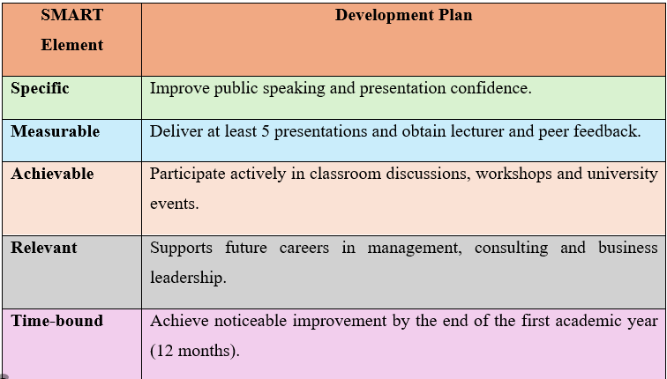
Table 2: SMART Skill Development Plan
(Source: Self-created)

1.2.4 Preferred Career Sector and Job Role
The general goal of mine on a long-term basis is to become a Business Consultant in the specializations like Business Strategy and Management Consulting. This career choice is suitable for me as I possess skills such as problem solving, conducting research, and communicating. The ability to analyze problems in business organizations and apply strategies which I have learned during the course is my main motivation. On the other hand, I understand that various other skills are also required for a career in management consultancy too. Such competencies like leadership, teamwork, commercial knowledge and professional networking are necessary for making a career within this sector. My personal branding by creating my portfolio, obtaining internship experience and professional networking will increase my chances to find a job.

2. Creativity

2.1 About Me (Website Content)
Being a student of Business Management at Ravensbourne University London, I became interested in strategic management and business consulting. Gradually, I realized the importance of flexibility, teamwork, and personal development with the help of feedback. It is to be noted that getting education is not only about getting high grades but also about getting practical skills and knowledge. I found it interesting to see how the complex business issues could be solved in companies and how they create long-term value for their clients through strategy and innovation. It is to be noted that as various employers who care about the digital footprint of the candidate, the importance of the professional online portfolio turns evident in terms of employability. Speaking about my long-term goals, I want to become a business consultant, capable enough for making strategic decisions and creating sustainable business growth for any company.

2.2 How My Website Represents My Personal Brand
The goal of my personal branding website is to showcase my professional and authentic achievements, skills and plans related to my future career. Not being just my digital CV, it is also the way to show the continuous development through the processes of reflective learning, classroom projects, professional experience and extracurricular activities. NOt only theoretical learning but also the skills of strategic thinking and professional development are the qualities I want to get in studying at Ravensbourne University.
The sections of my website have been selected in such a way to show my achievements and skills gained through my academic writing, teaching and collaborative work. Thus, my website presents not only the information about my achievements but also its impact on my professional development and my ambitions about my future work as the business consultant while regularly updating my professional achievements.

2.3 My Target Audience
My personal branding website has been created to meet needs of different audiences at different stages of my academic and professional career. Studying at Ravensbourne University, the main audience consists of my lecturers, classmates, guests of lectures, providers of internships and university staff who will assess my academic, professional and extracurricular activity. My website presents my learning experiences, projects and reflective practice as the proof of my capabilities outside the classwork. During the time of my graduation, my audience will expand and will consist of graduate recruiters, employers, professionals of the industry and my potential clients from the field of business consulting. In this way, I am going to regularly update my website with internships, certificates, projects and professional achievements..

2.4 Website Structure Diagram
The data in the personal website should be organised in a systematic manner thereby helping the user to find the information relevant to them.
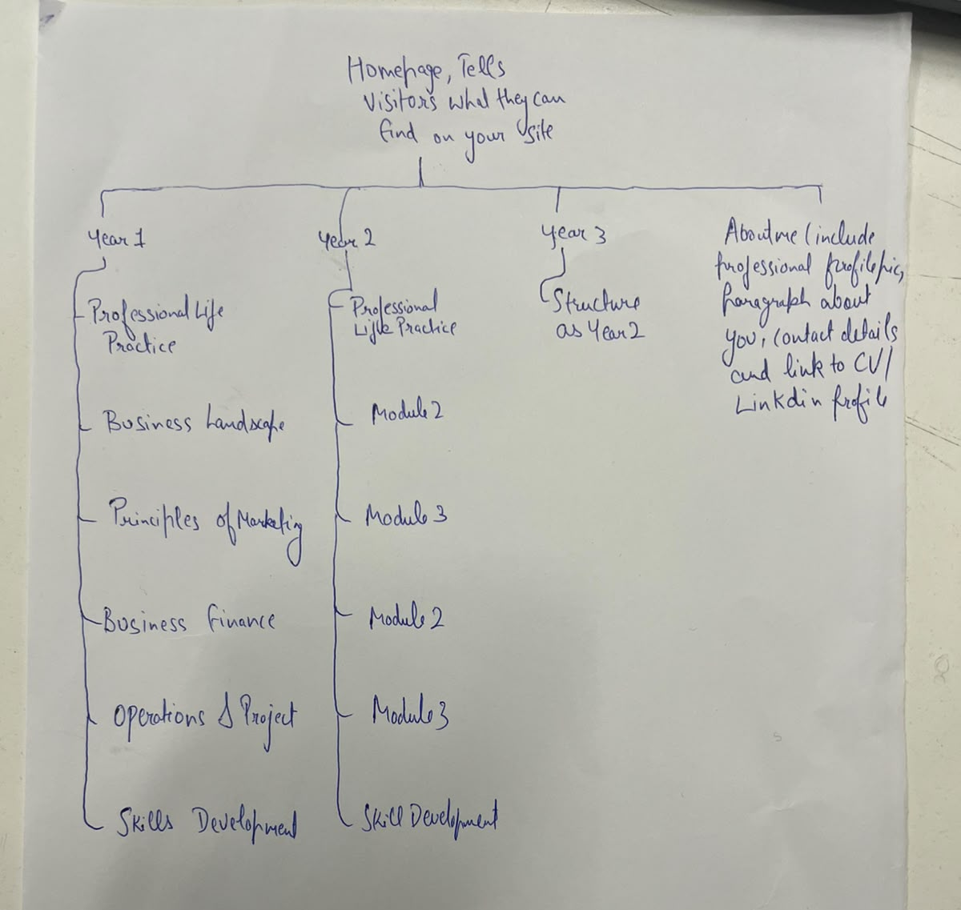
Figure 2: Proposed Website Structure Diagram
(Source: Self-created)
Figure 2 depicts the proposed structure of my personal branding website. The homepage will provide visitors with a brief overview of the website and direct them to the main sections, including my academic journey throughout Years 1, 2 and 3, skills development, and the "About Me" page. This structure will enable visitors to follow both my academic progress and professional growth during my degree. Furthermore, the "About Me" section, which includes my CV and LinkedIn profile, will strengthen my personal brand by presenting a professional and accessible online identity.

3. Connection

3.1 Events
Event 1: London Cultural Experience
My visit to Tower Bridge gave me an insight into the diversity of London and its importance for international business. Indeed, I always knew that the majority of people living in London are foreigners, but now, after this visit, I can really feel the diversity. The thing is that the diversity of perspectives influences the process of collaboration and communication. That is why future managers need to be ready to collaborate with people who are diverse. This visit made me open-minded and eager to develop my intercultural communication skills.

Figure 3: London Cultural Experience
(Source: London)
Event 2: Future Careers Connectivity Event
Participation in the Ravensbourne Careers and Employability Fair allowed me to know about the expectations that the employers have from representatives of the industry. Speaking with the recruiters and alumni, I understood that it is not enough to possess only knowledge of the academic field; good communication and networking skills are needed. Participation in employability activities makes people more career-ready and confident. This reflection taught me that it is important to communicate with employers, find internships and build a network. These activities made me more motivated to develop my employability skills.

3.2 Two Classroom Activities
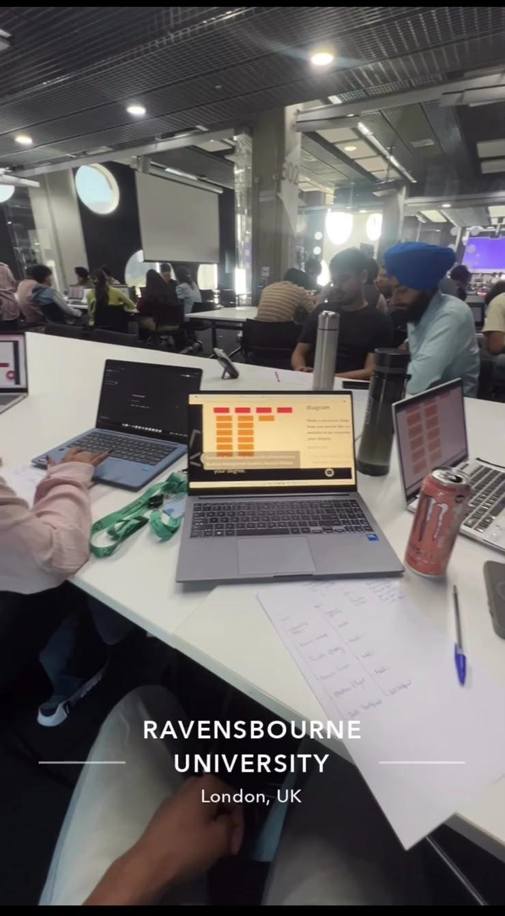

Figure 4: Group Branding Workshop
(Source: Ravensbourne University)
Participation in the Group Branding Workshop and Presentation Session was very useful for me both from the personal and professional perspectives. Collaborating in the branding workshop with my classmates such as Mehakpreet Kaur, Yuvraj Singh, Ramanpreet kauri and Mandeep Singh, I had to come up with some ideas and make decisions while collaborating. Initially, I emphasized on expressing my personal opinion but then realized that collaboration is all about listening, negotiating, and taking into account the perspectives of others. This experience helped me to be better prepared for collaborative problem solving.
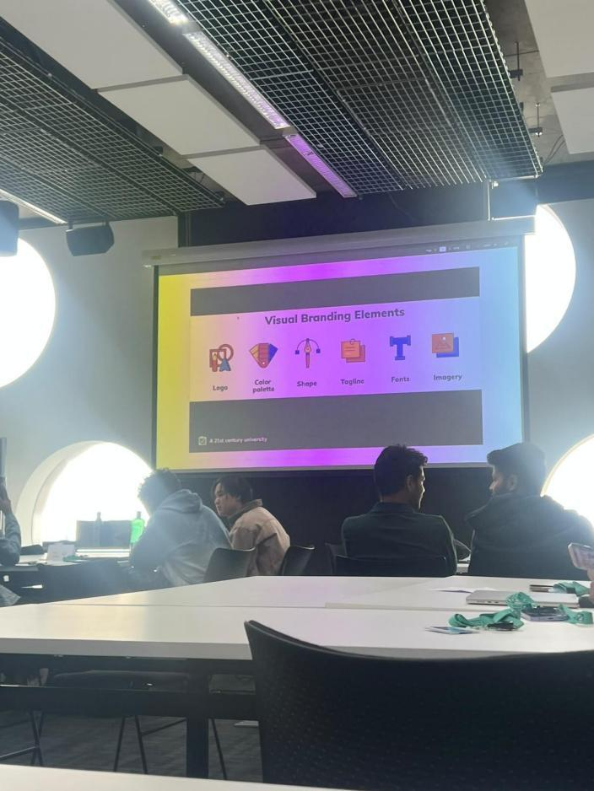
Figure 5: Presentation Session
(Source: Ravensbourne University)
The talent professionals highly value the soft skills of candidates and such skills as teamwork and communication, which I have developed in the classroom, are among them. Moreover, the presentation session helped me to overcome my fear of public speaking. The constructive feedback of the lecturers helped me to improve my communication style and organization of ideas. This reflection proves that these activities contributed to the development of interpersonal and leadership skills which are necessary for my future career in business consulting.

3.3 Three Personal or Professional Connections
Connection 1: Classmate
The most significant professional relationship with my classmates such as Mehakpreet Kaur, Yuvraj Singh, Ramanpreet Kaur and Mandeep Singh, allowed me to develop during this module is the connection with a classmate since we often discussed various issues in groups. While collaborating with another person, I had the opportunity to consider the issues from a different perspective and focus on teamwork. Initially, I used to do tasks on my own, but this collaboration made me realize the importance of listening, cooperation and respect to the perspectives of others. As it is said by Wells et al. (2024), teamwork is one of the most important qualities of graduates. This relationship helped me to develop my communication skills and realize the importance of collaboration.
Connection 2: Lecturer
The relationship with my lecturer Lisa Gee was very useful for my academic and personal development since getting the feedback on my presentations, writing and participation in the classroom, I had the opportunity to understand my strengths and weaknesses. Instead of considering the feedback as criticism, I took it as an opportunity to improve. This relationship made me more confident and actively participated in class discussions. It helped me to promote a growth mindset which will be useful for my future career.
Connection 3: Group Project Member
The relationship with a group project member made me realize that successful teamwork requires such elements as trust, responsibility, and communication. Although sometimes disagreement was the cause of the problems, respectful discussion of our opinions helped us to find more effective solutions. Teamwork and communication are the most important employability skills today.

References
HESA (2023). HESA - Experts in higher education data and analysis. [online] Hesa.ac.uk. Available at: https://www.hesa.ac.uk/ [Accessed 21 July 2026].
Kang, D. (2023). Prioritizing career preparation: learning achievements and extracurricular activities of undergraduate students for future success. Behavioral Sciences, 13(7), p.611. https://doi.org/10.3390/bs13070611
London Economics (2025). What employers want: The future of graduate skills and recruitment. Available at: https://londoneconomics.co.uk/blog/publication/what-employers-want-the-future-of-graduate-skills-and-recruitment-september-2025/
Szántó, P., Papp-Váry, Á. and Radácsi, L. (2025). Research gap in personal branding: Understanding and quantifying personal branding by developing a standardized framework for personal brand equity measurement. Administrative Sciences, 15(4), p.148. https://doi.org/10.3390/admsci15040148
Wells, R.S., Chen, L., Kimball, E., Annan, B., Auerbach, S.M. and Fermann, J.T. (2024). Improving the Perceived Utility Value of Teamwork and Collaboration among STEM Undergraduates. International journal of science and mathematical education/International journal of science and mathematics education. doi:10.1007/s10763-024-10471-5
World Economic Forum (2025). New economy skills: Unlocking the human advantage. Geneva: World Economic Forum. Available at: https://reports.weforum.org/docs/WEF_New_Economy_Skills_Unlocking_the_Human_Advantage_2025.pdf

